 | Kristann Mattes - CHAIR | x | Debbie Benson - VICE CHAIR | x | Kevin Woodard - SECRETARY
x | Randy Mendes | x | Sandy Dale | x | Sam Meredith
 | Rosemary Cummings | x | Jason Bretz | x | John Williams
x | Troy Van Bavel | x | Tim Hively | x | Tim Brown
x | Tom Vazquez | x | Matt Patton |  | Max Jones, Jr.
x | Charles Parker |  | Samuel Rodriguez |  | John Moffatt
 | Dane White | x | Nicole Ray |  | Steve Rocca
x | Maria

Action Item: Consent Agenda Items – Mattes

Committee Recommendation/Motion: Approval of August FFA Adult Board Minutes

John Williams moved to approve the Consent Agenda

Result of Vote: Pass

Report: Review of current 2020-21 Budget - Patton

No major changes have occurred. Patton stated that hotel contracts are being pushed out for three years. We will not be needing the allotment for national convention. State leadership conference planning for this year is ongoing. Requests for information have been made to Sacramento and we are awaiting reply.

(See Budget Update emailed to members 9-15-20)

Committee Recommendation/Motion: N/A

Result of Vote: N/A

Report: Update on CalAgPlate Program – Patton

Patton has been in contact with the CFA admin related to plans and promotion for ag plate program. Plans and promotions are in place and CFA was appreciative that these provisions were in place. Patton continues to emphasize the need to give away 1000 plates this year. This would bring in much needed income and ensure that we can continue to have this program. We must encourage every teacher to give away one at least one plate. Some difficulties with DMV have been seen so encourage those interested to continue to push for completion of the process. Social media is going to go out regarding the Cal Ag Plate program. Central Region has taken the position that we should pay to be included in the application that goes out in all of the mailers from DMV. In 2019 we received the $220,000.

((See Ag Plate Snap and Send, CalAgPlate Talking Points. FFA version _English_CalAgPlate, Ag Plate Incentives Flyer and CATA Dues and Plates_FINAL (emailed to members 9-15-20))

Committee Recommendation/Motion:

Sam Meredith made a motion to pay $35,000 to be included in the mailer from the DMV.

Meredith stated that the Central Region expressed support for spending the $35,000 to be included in the mailer from DMV. Additional discussion focused on the need for additional information or statistics as to the effectiveness of the program from others special interest plates programs. Positive comments about promotional materials prepared and sent to members.

Result of Vote: FAIL

Report: Update on State FFA Conference 2021 - Patton

We will not be needing the allotment for national convention. State leadership conference planning for this year is ongoing. Requests for information have been made to Sacramento and we are awaiting reply.

Committee Recommendation/Motion: N/A

Result of Vote: N/A

Report: FFA Foundation Update - Patton

Additional fundraising efforts have been ongoing. Foundation has been able to secure donors that previously dropped off.

Committee Recommendation/Motion: N/A

Result of Vote: N/A

Report: California Department of Education – Parker

- CDE employees not allowed in the Department office.
- Incentive Grant 77% of applications have been processed. Parker is hoping to see increases in the program in 21-22.
- AIG application changes continue to be reviewed by stakeholders. Planned implementation of new standards 23-24.
- Department of finance says that no changes are expected in budget. (Patton)

Committee Recommendation/Motion: N/A

Result of Vote: N/A

Action Item: Fee Waivers - Patton

Summit Charter Collegiate Academy requests a waiver for $100 assessment for Leadership Conference materials. Cost is prohibitive at this time.

Committee Recommendation/Motion:
Sandi Dale moved to accept the waiver from the Summit Charter Collegiate Academy

Result of Vote: PASS

Action to be taken by Members before the next meeting:

- Patton will contact DMV for timeline and additional information about Ag Plate promotion.

Date of next Meeting:

- January 29, 2021
- June 20, 2021

Time Meeting Adjourned: 4:50 PM

Name of person taking minutes: Kevin Woodard

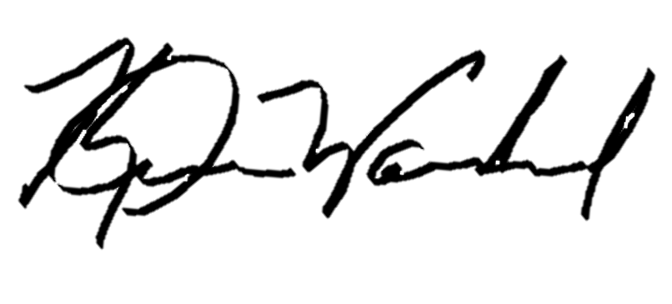
Signature of person taking minutes.

