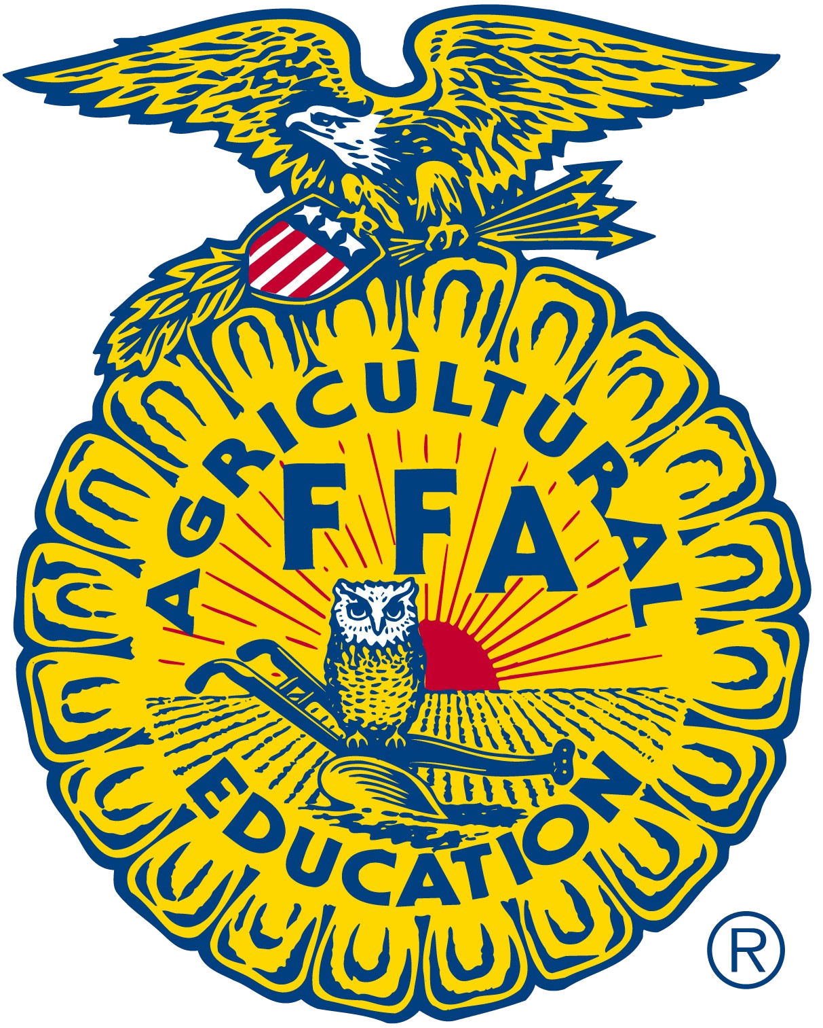
FFA Adult Board of Directors
Minutes
September 23rd, 2019
California State FFA Center, Galt CA.

Call to Order: Kristann Mattes

Consent Agenda Items –  (Action - Mattes)  Approval of June FFA Adult Board Minutes  Move FFA Adult Board Election/Re-election | Motion to approve as submitted -  Second  Discussion – No additional discussion  Action – Motion Carried
Financial Services Report  (Report - Maberto)  2018/2019 Association Budget Activity  2018/2019 Regional Budget Activity | Maria Maberto reviewed activity as of June 30, 2019.  Patton clarified that the Net Profit/Loss of $185K consisted of $120K that the board dedicated to address Live-Light. Moffatt questioned State Officer expense increased, Maberto identified that it had to do with the timing of payments.  Maberto reviewed regional activity. Moffatt inquired about paydown of reserves by region, Maberto identified that this would be addressed in the 2019-2020 report.  Motion to approve as submitted – Sam Meredith  Second – Tim Brown  Discussion – No additional discussion.  Action – Motion Carried
CalAgPlate Update  (Report - Patton) | Patton stated that to date the CAFFA has received $1,200,000 ($210K per year) from this program. Our original investment was $250K and with additional contribution we are in the program for $273K. CDFA stated that we can expect a letter from DMV requiring that we our current 5,900 plates on the road needs to be increased to 7500 or we may lose this program. Last year we had a goal to give away 1,000 free plates and we only gave away 69 plates. Members questioned why the numbers have declined. Patton identified that non-ops and non-renewals is the greatest cause. It was identified that the “AG PLATE” was not on the custom plate form from the DMV because it was cost prohibitive.  Patton Proposed that $150K be spent over two years ($75K each year) to purchase additional plates (2000 plates) for “Giveaways”. Additional ideas included a $50 incentive to dealerships who sign up new  Motion - Tom Vasquez moved to allocate $150,000 ($75,000/year for two years) to purchase additional plates to reach our 7,500 plate targets.  Second – Sam Meredith  Discussion – Questions related to the how we would increase the total number required. Patton stated that he promoted the program through articles in trade papers. Sandy Dale identified that “Fleet Sales” from agriculture companies resulted in a large amount of new plates issued. This needs to be a BOLD stated item at each of the regional meetings. Moffatt identified that our $40 investment results in an automatic return of $30 to CAFFA. This means that an investment of $150K is actually $37,500. If only half of those plates are renewed, we are still ahead.  Action – Motion Carried
Update of 2019/2020 Association/Regional Budget  (Action - Maberto) | Maberto reviewed proposed budgets for the next fiscal year. The board addressed concerns about the Greenhand Leadership Conferences. Many of the members identified that interest in GLC’s has declined. Parker asked what the major issue was. Members stated that curriculum was a major issue along with time conflicts, programs putting on their own freshman conferences, teachers not “front loading” information prior to conference. Moffatt questioned the quality of presenters. Parker stated that we have so many conferences that we need a greater number of presenters. Dale stated that there is a number of other events that we compete with.  Participation in National Convention and DC Trip numbers are down (146 Nationals and 180 DC). Parker complemented FFA Center staff and State Staff for streamlining and organizing for cost savings. Cummings questioned if the decrease in numbers was related to the number proficiencies attending. Parker identified that we were down last year as well. Parker also stated that Dane White was in charge of the DC trip and a renewed focus would be on education during that activity.  Maberto reviewed the Regional Activity as of August 31.  Moffatt addressed the discrepancy in quantity of reserves remaining. Superior region donated a quantity of budget to the Southern Region because their reserves were “spent down” by previous regional supervisor. Parker asked for consensus from the board as to an amount that each regional supervisor should keep in reserves.  Motion to accept as submitted -  Second  Discussion  Action - Motion Carried
2018-2019 Audit Recommendations  (Action - Maberto) | Key recommendation were as follows:  - Maria and Jennifer not be tasked with signing checks.  - Patton and one officer of the Board are signers.  It was recommended that do to his close proximity, John Moffatt be identified as the Board’s representative. Patton agreed but recommended that digital options be researched. Moffatt agreed.  Motion - Rosemary Cummings moved to add John Moffatt as a signer for any checks over $10,000 until a digital option is identified.  Second – Sam Meredith  Discussion – No further discussion  Action – Motion Carried
2020 Budget CA FFA State Conference  (Report – Mayfield) | While the board waited for Mayfield to address the board, Patton discussed the proposed budget compiled by Mayfield for the 2020 CAFFA Leadership Conference. This budget identified options for $22, $210, $200 per member.  Discussion pertaining to the accuracy of the current budget as it relates to detail. Items such as supplies increased dramatically over last year. Identified savings was not addressed for the switch to KBF in 2020 from Disney in 2019.  THE CHAIR TABLED DISCUSSION UNTIL MAYFIELD COULD ATTEND.  Later in the meeting Mayfield joined the meeting and discussion resumed.  Looking at the proposed budget from Mayfield was analyzed by members of the board with questions for clarification. Many of the line items that had increases over last year seemed to lack accuracy and detail. Members of the board asked Mayfield to firm up the budget and present a greater level of detail. Mayfield returned with a recalculated budget and presented it to the Board. After analyzing the revised budget, it was evident that the level of detail was still not sufficient to approve. Mayfield agreed to prepare a detailed budget (at the level presented to the Board last year.  Continued discussion ensued related to transportation to KBF but no decision was reached.
Entertainment for CA FFA State Conference (Action - Patton)  Disney Proposal  California Adventure  Knott’s Berry Farm Proposal | DISNEY, CALIFORNIA ADVENTURE  6,500 Participants. 4:00 PM until 1:00PM  (four hour open park and four hours exclusive)  $620K Initial Quote ($540K in 2019)  Once they found out that we were talking to KBF they offered 2019 numbers. Patton asked if 2018 prices were possible. He asked Mayfield to inquire.  KNOTT’S BERRY FARM  5,500 Participants. 6:00 PM to 11:00 PM  (five hour exclusive event)  $325K ($50 per participant)  Busses are currently estimated at $30K to transport students from convention center to park. Parker will research additional options for bussing. Parking Fee: A flat parking fee of $4,000 will be charged for all vehicles.  Most regions preferred that the board choose Knotts Berry Farm (North Coast was 100% in favor of Disney).  Motion: Tim Hively moved that we proceed with the Knotts Berry Farm entertainment at state conference.  Second: Jason Bretz  THE BOARD RECESSED FOR LUNCH  Discussion: Discussion related to busses highlighted issues of equity for chapters that do not have transportation. Who will pay for the busses? Who will use the busses? How do we charge for busses? How many busses will be needed to move 6,500 people to KBF to and from the event in a timely manner. Dale identified that those programs that need busses have already paid a higher price for transportation (busses, airfare). It was asked how we could span the cost over all members but only allow bus and airfare to attend conference. Patton stated that Mosaic was talking to South West for reduced airfare rates, but nothing has been reached. How much of the park at KBF will be open? All of it  Action: Motion Carried, Hand Vote
Live Light update  (Action - Patton) | In May we received a request of $900K. We replied that we deny their request. Our lawyer (Ladderback Group) dissolved and our lawyer moved to another firm and we followed. He is no longer with that firm. We have been in contact with our current council (from SMG case) and we were given a contact in a new firm in San Francisco. We received a contract from our lawyer establishing a relationship. Originally, Mayfield was going to be questioned by council to identify what had happened in the process. Moffatt questioned if we still need to think about not having Mayfield questioned. Moffatt suggested that we wait this thing out and talk to other council to identify fees and contracts. Members mentioned that we still have original allocation for legal feed related to Live Light case. It was recommended that the board gives Patton the authorization to research representation. In the event that we are served we will need to convene a meeting of the board to address. Moffatt suggested that we identify council in Fresno area to save on costs related to travel from northern California.  Motion:  Second:  Discussion:  Action: NO ACTION TAKEN
Update on Fresno/SMG Lawsuit  (Report - Patton) | Lawsuit with SMG has been settled, insurance company paid settlement. We are awaiting confirmation on payment of $10K for deductible. They have not reached out to us as of this meeting.
Transfer of FFA Center –  (Report - Patton) | Patton stated that the paperwork has been filed and is in the process of confirmation. Matt will advise as we hear word.
State FFA Advisor Report –  (Report - Parker ) | No additional items to report.
CATA Report – | (Report - Patton)  Patton discussed  AB48 $15 Billion in Facilities Funds  SB328 Early Start for k-12 has made it to the governor’s desk. There is no indication as to Newsom’s position at this time.  State Plan for Perkins has two items that concern our programs. CTSO’s include an example of “Other” that is not identified. Credentials are also in question within this plan.  Golden Slate – Patton stated that the Golden Slate will go to a monthly digital format. Dale asked if there would still be a “hard-copy” printed. Patton said that there will not. North Coast still wanted some hard copies for those that still prefer this option. Patton recommended that we may have to ask regional officers print a copy off for those individuals.
FFA Foundation Update -(Report - Otto) | No report at this time
Senior Conference/ GLC/ ALA/ MFE Update –  (Report - Garrett) | Hannah Garret presented the board with findings of a $5,000 pilot Senior Leadership Conference. Garrett stated that the experience was valuable to the attendees. A proposed budget was presented and explained to the Board. Being that this was a and informational report, no action was taken by the board.
2023 and 2024 CA State FFA  Conference update –  (Report - Mayfield) | Patton presented that Long Beach is in question do to scheduling so we are going to be looking at Ontario. We are an attractive client to these cities so we may have some leverage. Rodriguez identified potential issues that teachers in the state may object to a “Top Down” directive from the Board. Patton replied that we are only looking to gather information so that it can be addressed. Mayfield identified that our limiting factors have to do with a large enough arena and the costs associated with union worker requirements. Additional discussion related to staying in the Sacramento area but any other arenas in the area. Mosaic stated that it is about 200 hours to develop contract proposals. Meredith asked Mayfield to return to the meeting with a firmer budget while Parker gave his report. Mayfield agreed.
Other Business – (Mattes)  Reimbursement Rate  Consideration of Waivers  Contract with Cogent | Motion – Steve Rocca moved that we update the reimbursement rate to coincide with state rates for all staff and contract employees.  Second – John Williams  Discussion – No further discussion  Action - Motion Carried  Princeton Union School District $325 reimbursement for State Conference 2019 late fees do to school closure.  Motion – Tim Brown moved to reimburse the district for late fees totaling $325.  Second – John Williams  Discussion – No further discussion  Action - Motion Carried  Motion – Sam Meredith moved to ratify the contract with Cogent for media promotions and design work.  Second – Jason Bretz  Action – Motion Carried
Adjournment – Mattes

