x | Kristann Mattes - CHAIR | x | Debbie Benson - VICE CHAIR | x | Kevin Woodard - SECRETARY
x | Randy Mendes | x | Sandy Dale |  | Sam Meredith
x | Rosemary Cummings | x | Jason Bretz | x | John Williams
x | Troy Van Bavel |  | Tim Hively |  | Tim Brown
x | Tom Vazquez | x | Matt Patton |  | Max Jones, Jr.
 | Charles Parker | x | Samuel Rodriguez |  | John Moffatt
x | Dane White | x | Nicole Ray | x | Steve Rocca

- Approval of Minuets: ACTION ITEM Mattis
  - 5-21-20 Motion: Jason Bretz Second: Steve Rocca Motion: Carried.

- 2020 State Leadership Conference Financials REPORT Patton

TREDITIONAL CONFERENCE BUDGET
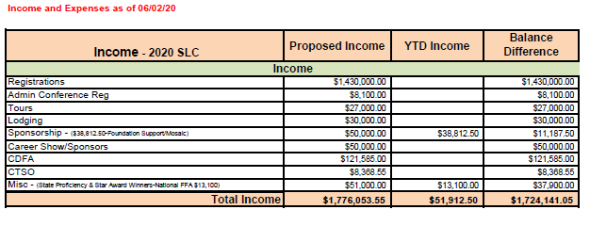
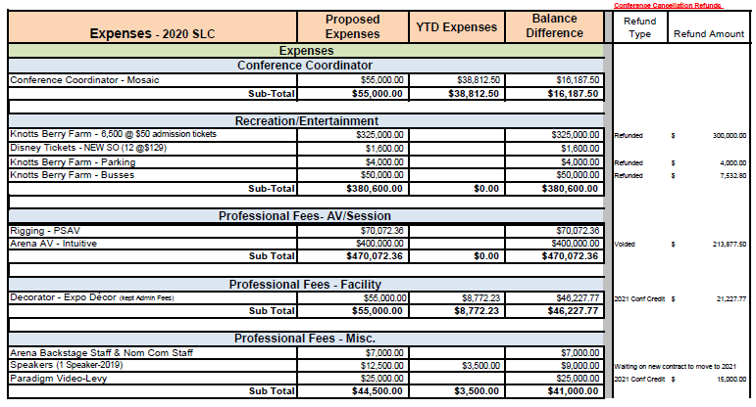

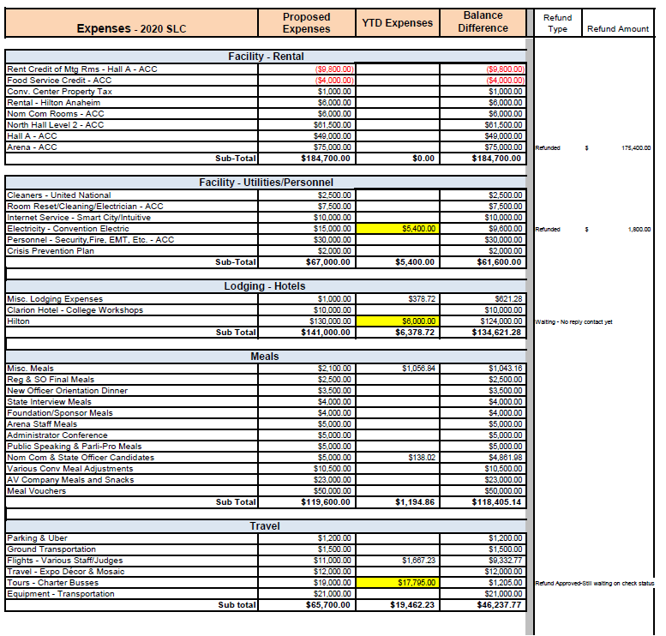
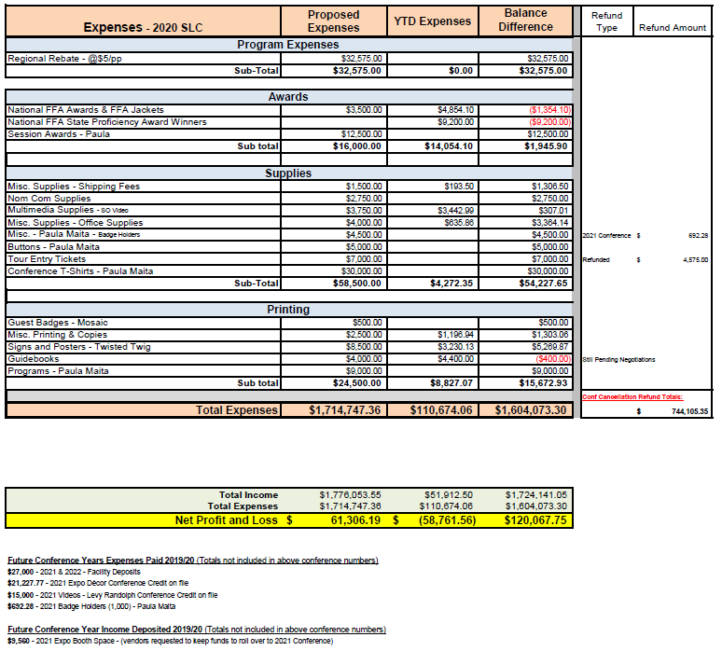

VIRTUAL CONFERENCE BUDGET

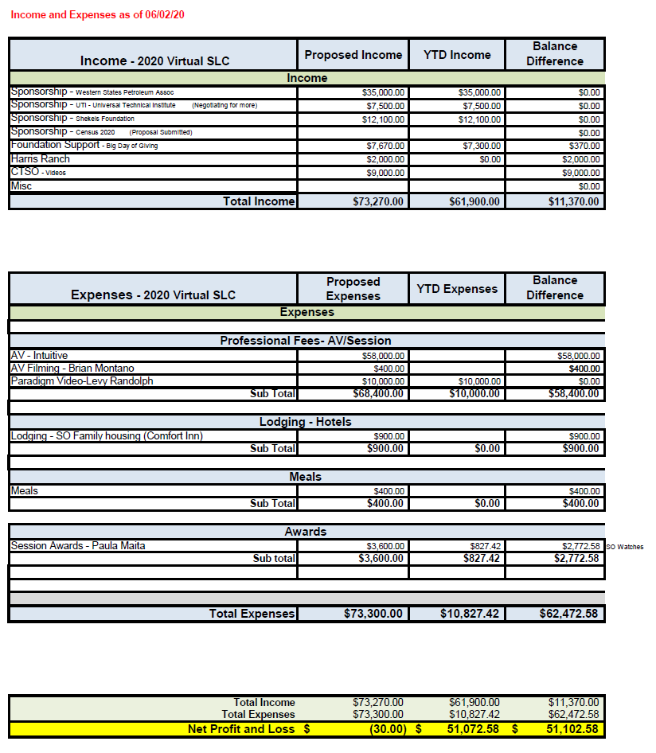

- Chapter Fees for 2020 State Leadership Conference ACTION ITEM Mattis
  - Background – Mr. Patton reviewed the gave examples of various costs associated with the virtual conference. Although much of the original budget was or will be refunded and significant contributions from sponsors, a significant loss of approx. $30,000 will be incurred. In an effort to minimize this deficit, Mr. White brought forward a plan to develop a set of curricula that would be connected to the 2020 virtual conference and could be used by the chapters for leadership development. This curriculum could come at a cost to each chapter to offset the cost of the conference.
  - Conference Fees – A lengthy discussion took place regarding the possibility of charging chapters a fee to access the conference curriculum. Throughout the planning process it has been the boards intention to provide a “free of charge” experience for the virtual conference, the consensus was that would only come at a significant loss to the association.
  - Motion - Sandy Dale moved to authorize a charge of $100 to each chapter for the state FFA Leadership Conference. The motion was seconded, and discussion followed.
  - Discussion – Discussion focused around the impact that imposing a conference fee would have on chapters. It was reported that some regions had already expressed support for assessing a fee. It was mentioned that normally there is a fee for chapter delegates and that there was not a charge this year. Realizing that some districts have already closed purchasing windows for this fiscal year, concern was expressed that some chapters would not be able to pay the registration fee. A question was raised as to the consequences if a chapter is not able or chooses not to pay. It was conceded that carrying these fees as a payable into 2020-2021 or allowing for a “hold harmless” petition process could be established. Mr. Mattis reminded the members that AIG funds had be extended until September 30th and that those could be used to pay fees as well. It was suggested that the association send invoices as soon as possible so that those chapters that do have funding available could remit payment quickly.
  - Question Called – Debate ended. Motion Carried

- Questions/Comments

- Meeting adjourned at 4:25 PM

NEXT MEETING
June 26, 2020
2:00 PM
FFA Center Galt and via ZOOM

