On February 25, 2020, the following message was sent to members of the California FFA Adult Board. Board members were asked to read the proposal for expanding the part-time clerical assistant for the FFA Association to a 20 hour per week position. Previously the position was funded by both the Association and California FFA Foundation. Board members were asked to vote for the proposal by e-mail. A majority of the board responded with a yes vote to the proposal.

|  |  |  |  |  |  |
| --- | --- | --- | --- | --- | --- |
| X | Kristann Mattes - CHAIR | X | Debbie Benson - VICE CHAIR |  | Kevin Woodard - SECRETARY |
|  | Randy Mendes | X | Sandy Dale |  | Sam Meredith |
|  | Rosemary Cummings | X | Jason Bretz | X | John Williams |
| x | Troy Van Bavel | X | Tim Hively | X | Tim Brown |
| X | Tom Vazquez |  | Matt Patton | X | Christie Fuso |
|  | Charles Parker |  | Samuel Rodriguez |  | John Moffatt |
|  | Dane White |  | Kayla Zalesny | X | Steve Rocca |
| X | Nicole Ray |  |  |  |  |

FFA Adult Board

Last Friday we conducted interviews for the part time clerical assistant for the FFA Association. This position was previously staffed by Trisha Chapman. Trisha has transitioned into the membership services position formally held by Jennifer Stockton.

There were two outstanding candidates that greatly impressed the interview committee. In addition to having outstanding skills related to the position, both individuals are long time Galt residents with strong roots in the community and are passionate about the FFA.

This presents an opportunity for two-part time employees to be hired at the FFA Center. One employee would exclusively serve the FFA Association and the other would be split between CATA and the Foundation. The current clerical assistant position is funded by both the FFA Association, FFA Foundation, and a stipend for extra duties related to booking National Convention. This stipend is paid for by the Association.

What is being proposed is that one of positions becomes totally funded by the FFA Association. This would require an additional $8,000 annually from the Association. This additional cost would be gradually realized over the course of several years. Jennifer had progressed six steps on the pay scale because of years of service. Trisha is new to the position she starts at year one on the same scale. This difference in years, will result in a reduced cost of $10,000 to the Association during the 2020/2021 fiscal year. This savings in salary could be applied to eliminate the contribution by the FFA Foundation and make the position strictly for Association activities. Initially this transition would not have an additional cost to the Association, but eventually as years of service are accumulated the cost would increase.

Below is the pay scale that would be assigned to the FFA Association Clerical Assistant position.

Modifications of the budget midyear should be approved by the FFA Adult Board. Please respond to this e-mail with a yes or no in response to expanding the FFA Association budget to hire a FFA Association Clerical Assistant.

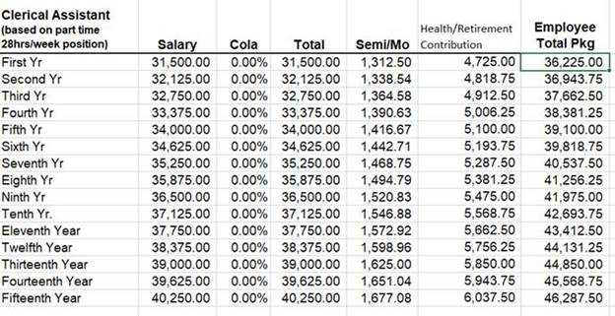

Respectfully,

Matt Patton

*Executive Director*

*California Agricultural Teachers’ Assn.*

*California FFA Foundation*

*P.O. Box 186*

*Galt, CA  95632*

*Phone: 209 744-1605*

[*mpatton@calagteachers.org*](mailto:mpatton@calagteachers.org)