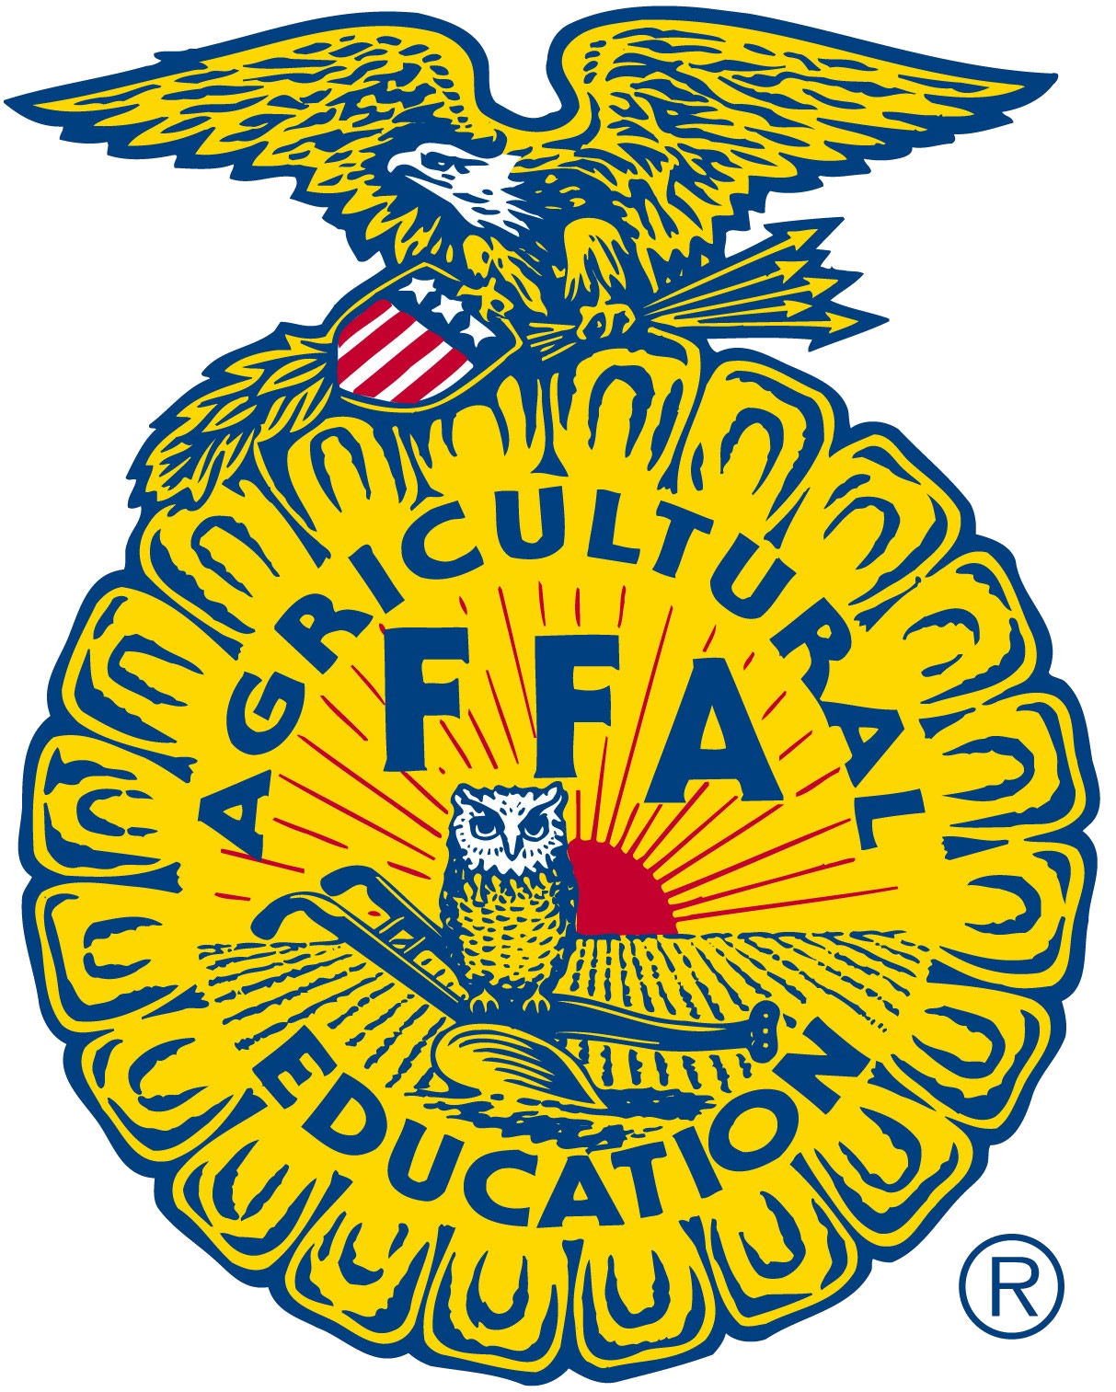
FFA Adult Board of Directors
Minutes
November 14, 2019

TELECONFERENCE
Dial-in-number; 712-775-7031
Access Code; 355-768

Call to Order: Kristann Mattes

Review of the 2020 State Conference budget (Discussion) | Rigging price increase  Facilities cost increased  2020 Attendance Goal is 6500  2019 Attendance was 6333 with 476 “One Day” and 54 Administrators.  Patton reminded the members that we are still operating under a budget that was prepared by Mr. Mayfield and that we are only going off of his numbers.
Discussion of hotel block obligations (Report) | Patton reported that we are in contract discussions with Hilton Hotels and that our existing agreement for 990 rooms (increase of 150 over last year) and that is with a stipulation that we book 80% (792) of the contracted rooms to avoid $40K penalty. Rooms are $226 each.  Last year 32 of the 658 rooms were used for state staff and administration during conference. This year that number will increase.  Director and State Staff will continue negotiations and report back to the board with any changes.
2020 State FFA Conference registration price determination (Action) | The board was presented with various versions of the 2020 conference budget. Each version ($210-$215-$220) would result  Motion: John Williams  To set the registration cost at $215 pending negotiations with Hilton be resolved or it will be moved to $220.  Second: Sandie Dale.  Discussion, Sandy Dale recommended that if we set the registration to $220 and if negotiations “go well” we can move it down to $215 or $210.  Amendment: Sandie Dale  Strike out $215 and insert $220. The friendly amendment was accepted by the maker of the motion.  Discussion: Members discussed concerns of timing for reports to regional meetings. It was encouraged that at regional meetings we do not mention a registration fee until we have more information is secured.  Amendment: Troy VanBavel  To strike out “with Hilton”. The friendly amendment was accepted by the maker of the motion.  Discussion: None  Motion Carried.
Visitation of Potential Convention Sites for 2023 | Motion: Rocca  To have three representatives from the Board visit Ontario during NAAE to explore its potential for future conference.  Second: Tim Hively  Discussion: Kevin Woodard, Kristann Mattes and John Williams identified that they would be present and available.  Motion Carried
Adjournment – Mattes | Motion: John Williams  Second: Jason Bretts  Discussion: None  Motion Carried

