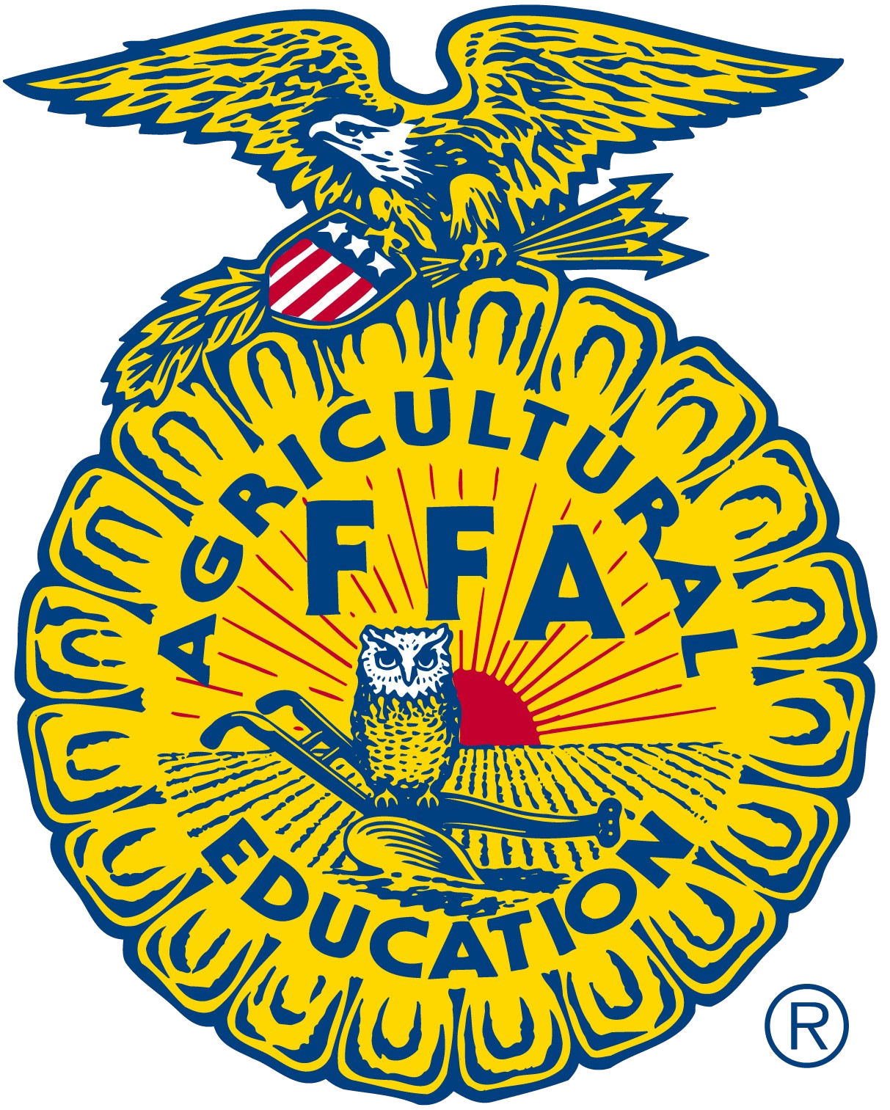
FFA Adult Board of Directors
Minutes
June 23rd, 2019
Cal Poly, San Luis Obispo

Call to Order: Kristann Mattes

Old Business

Move the Consent Agenda Motion: J Williams Second: R Cummings

- Approval of Minutes – (As submitted) K. Woodard
  - January 17th, 2019
  - March 11th, 2019 – Phone Conference
  - April 4th, 2019 – Phone Conference

- Financial Services Report – Maberto Motion: D. Benson Second: R. Mendes
  - 2017/2018 Association Budget Activity
Budget activity as presented by Maberto. State Leadership Conference – We are $120k ahead ($297k - $150k). Net Profit/Loss $178k.
  - 2017/2018 Regional Budget Activity

- State FFA Leadership Conference Budget – J. Mayfield (Report)
- Live Light update – M. Patton (Action)
Mrs. Mattis explained that there is a current dispute between the California FFA and Live Light. She clarified that any discussion with or in front of potential deposable individuals could not be done. We can ask questions but not discuss. Mayfield was asked how 17-18 numbers came into play in Live Light’s submission. He said that some of the rigging fee for the 2018 conference was justified. Mayfield did not specifically ask them if the additional equipment could be rented. Mayfield stated that his impression was that any discussion of future costs were only budget estimates and not contracted prices.

With concern related to potential investigation, the board continued to discuss specific strategies in the absence of state staff members.
- State FFA Advisor Report – C. Parker (Report)
Mr. Parker expressed his pleasure that the CDE for Ag Education is whole again and that a new visioning can take place moving forward. He recommended that thank you letters are sent off to Mr. Thurmond

- CATA/FFA Foundation Update - Patton (Report)
New Business
- Adoption of 2019/2020 Association Budget (Action)
01 Advanced Academy
- Included projected late fees based on 70% of the last three year average. Calculated at $3500.
- Reduced professional services from $12,000 to $3,000 by reducing staff and using State Officers to present.

02- Affiliation
- Reduction of regional rebate from $.50 to $.40 per member
04- FFA Center
- Reduction in facilities repair from $15,000 to $8,000.
05- FFA Promotions
- Reduction in design work from $9,600 to $2,000.
- Reduction in CalAgPlate Promotion from $10,000 to $5,000.
- Elimination of the World Ag Expo Both booth (2,000).

07- Financial Office
- Reduction of operating expenses by $3,500.

08 – Greenhand Conferences
- Increased student registration fees from $35 to $40. Last fee increase was 7 years ago. Increase in revenue estimated at $26,690.
- Budget includes projected late fees based on 75% of the last three year average. Calculated at $7500.

09- Made for Excellence
- Budget includes projected late fees based on 64% of the last three year average. Calculated at $4500.
10- National Convention
- Elimination of suite - $2,500 (facility) + $1,500 (food/refreshments) = $4,000.
- Reduced staff meals in DC from $9,000 to $4,000.
- Budget includes projected late fees based on 50% of the last three year average. Calculated at $1500.
15- Regional Officer Leadership Conference
- Reduced supplies $300.
- Recommend researching alternative locations for 2020 ROLC.

16- Sacramento Leadership Experience
- Reduced facility and lodging by $1,000.
- Reduced meals by $1,000.
- Reduced travel by $800.

18- State executive/advisory/adult board committee
- Reduced hotel by $500.
- Reduced meals by $250.
- Reduced travel by $1,350.

20- State Leadership Conference
- Reduction in estimated Mosaic event planner fee from $100,000 to $71,000.

21- State Officers
- Reduction in meals $2,000.
- Reduction in travel $3,000.
Discussion on the above budget reductions related to priority
Current Cost Per Member
National Dues $5.05AET $1.81, State Officers $1.00, Promotions and Website $1.00
Staff $1.00 Total = 9.89 ($8.50/Student: Revenue. -$1.39)

Jason Bretz moved to increase membership affiliation fee to $10 per student. Second by Tim Hively. Discussion followed. Motion Passed, voice vote. (results in a $139k increase in revenue)
NOTE: Strike through items above were removed from the 2019-20 Association budget.
Motion: T Hivley Second: S Meredith

- Adoption of 2019/2020 Regional Budgets

- FFA Adult Board Election/Re-election Moved to Fall Meeting

- Recognition of retiring Board Members (Report)

- Other Business

  - Rosemary Cummings moved to adopt the submitted reimbursement schedule for meals and mileage payed to state officers.
  - Seconded Tom Vasquez.
  - Discussion followed. Motion Passed, voice vote

- Adjournment

