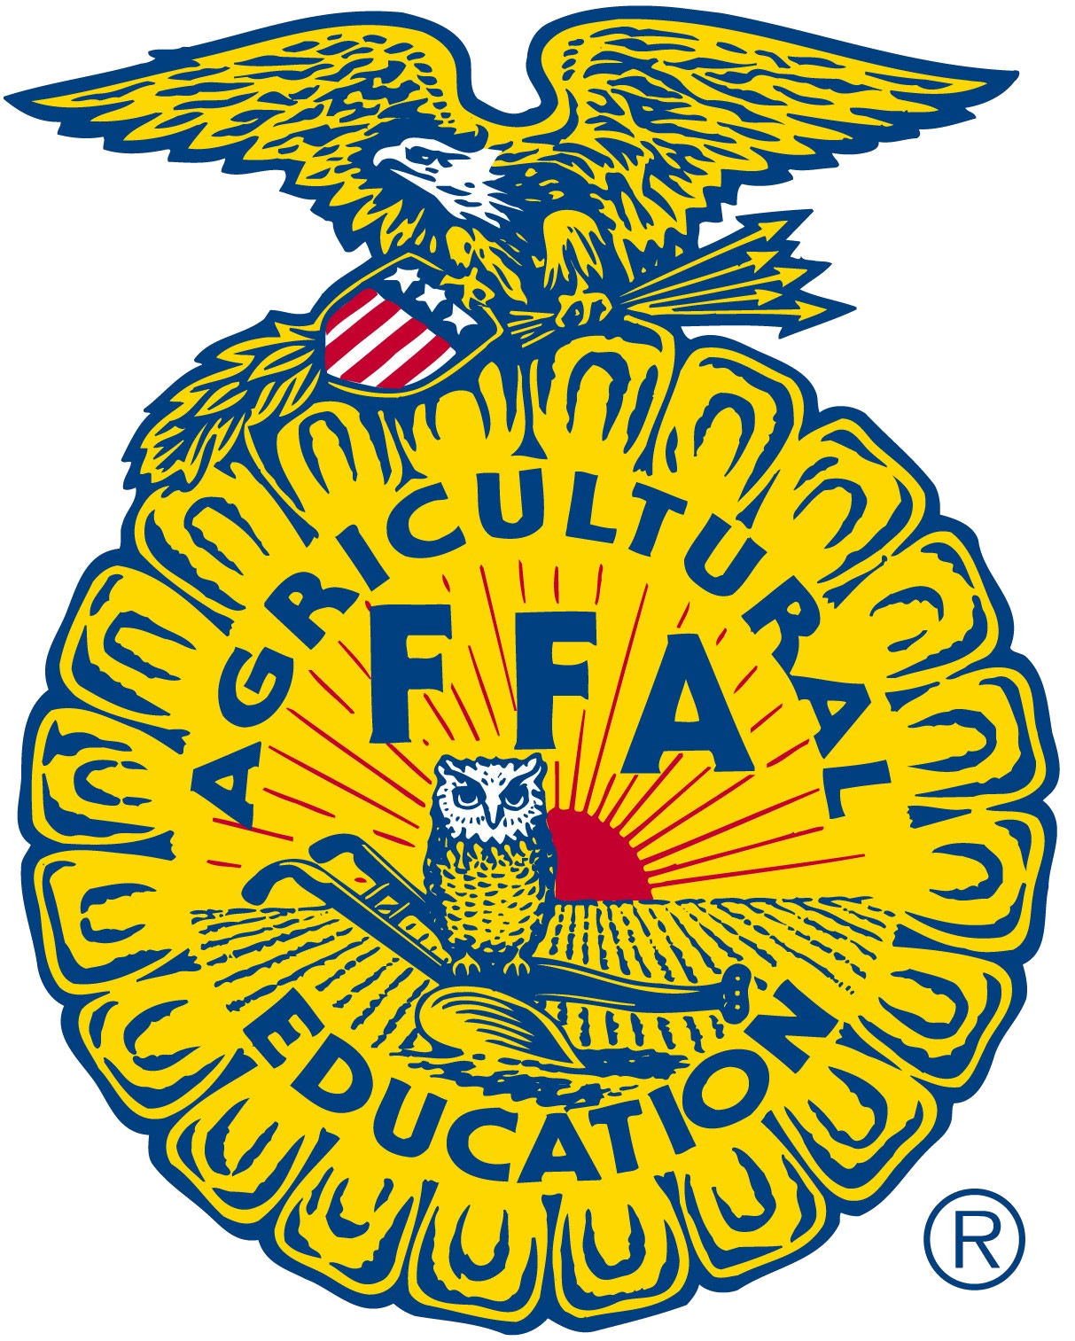

FFA Adult Board of Directors
MINUTES
April 4, 2019

A supplemental conference call meeting of the California FFA Adult Board was conducted on April 4, 2019. Kristann Mattes the board president called the meeting to order at 3:03 p.m. Matt Patton verbally called roll and verified a quorum.

Josiah Mayfield reported that 6,296 full time participants and 157 one day participants had registered for the 2019 California State FFA Convention in Anaheim. The budget for the conference was reported to be on par with the board approved budget for the conference.

Katie Otto reported that booth income from the Expo had generated $42,475 and that $36,400 in sponsor donations have been received. Both booth sales and sponsorships were above last year’s levels.

The general consensus was that the budget for state conference is in good shape and that no adjustments need to me made before the conference at the end of the month.

Kristann Mattes adjourned the meeting at 3:27 p.m.

Respectfully submitted,
Mathew Patton
Executive Director
California Association FFA, Adult Board of Directors

